E. Polymerization of Styrene
Introduction
Purpose:
To synthesize polystyrene, with benzyl peroxide as a polymerization initiator, by radical polymerization of styrene. We then measured its infrared absorption technique using Fourier transform (FT) infrared technique and discuss its molecular structure.
Polystyrene synthesis
Styrene is made from ethylene and ethylbenzene, which are obtained by fractional distillation and synthesized from benzene, respectively. (Scheme 1(1)). Ethylbenzene is designated to form styrene. (Scheme 1(2)).
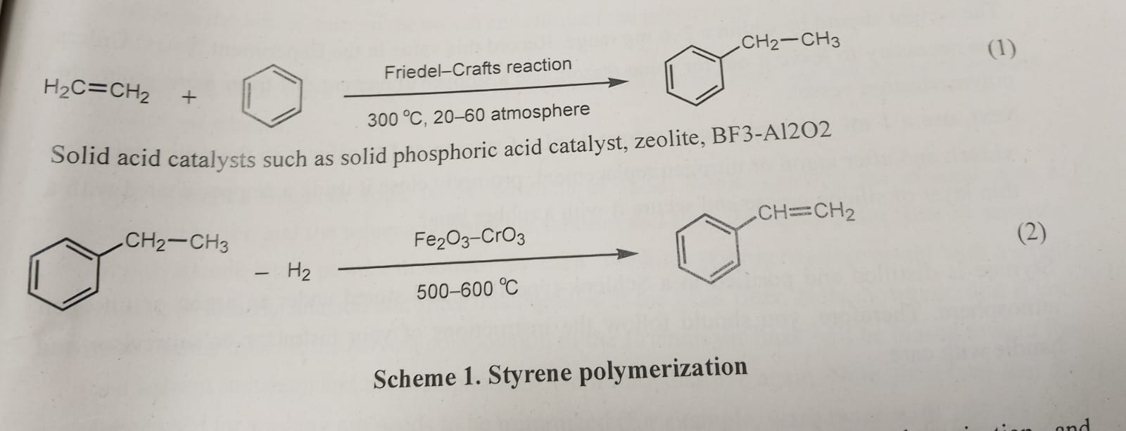
In this experiment, the polymerization experiment is caused by radical polymerization. (Scheme 2) and (Figure1)
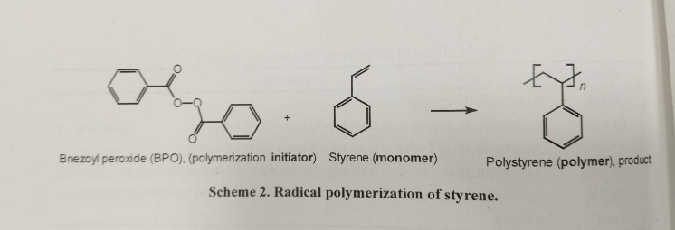
In the case of radical polymerization, the initial reaction usually involves a polymerization initiator that generates radicals upon heating. Benzoyl peroxide(BPO) is used as the initiator for radical polymerization in polymerization in this experiment.
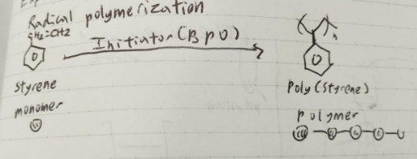
Figure 1 The radical polymerization of polystyrene in this experiment

Experiment Day 1: Styrene Polymerization (6th October)Day 1:
- Measured the weight of benzoyl peroxide in powder form (white powder). The weight of benzoyl peroxide should be within 2-6 mg range. If the weight is too much, there is too much acceleration happening in the polymerization reaction. On the other hand, if the weight is too small, the activity will be slow.

For my experiment, the weight of the benzoyl peroxide is 3.9 mg.

Next, a 1mL micropipette was used to extract 1 mL of styrene and transferred it to the polymerization vessel. The polymerization vessel was then given an argon replacement, where the vessel was stored under the argon atmosphere and the argon gas is inserted into the polymerization vessel. After the argon replacement, I closed it using a stopper coated with thin layer of silicone grease( the molecular structure of silicone is in Figure 2) and secured it using a rubber band.
Silicone is used as an oil.
Styrene is distilled and purified in a Schlenk flask and stored under an argon atmosphere.
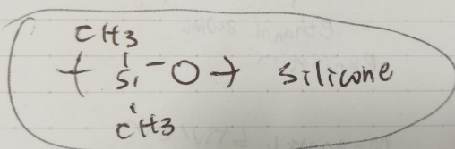
Figure 2 Structure of silicone
- The container was carefully shaken to dissolve the benzyl peroxide. Once it was completely dissolved, the container was placed in a thermostatic bath and secured with a clamp to start polymerization. The thermostatic bath was set to 75 degrees Celcius.

The experiment was left as it is until the next day of the experiment.
Experiment Day 2: Refinement and Recovery of Polystyrene (16th October)
- The polymerization vessel was taken out of the thermostatic bath. The polymerization vessel was set in the magnetic stirrer. 20mL of toluene was added using the volpipette and safety pipette (The vollpippete was attached to and below the safety pipette, and I added 20 mL of toluene by operating/pushing the safety pipette until the volpippette was filled with toluene). The magnetic stirrer was turned on until all of the styrene was dissolved. (Figure 4)
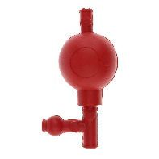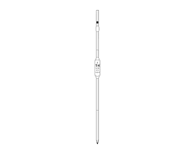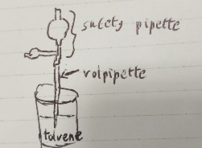
Figure 3 safety pipette and volpippette, respectively (left to right). The volpippette was inserted to the safety pipette so that the safety pipette is above the volpippette.
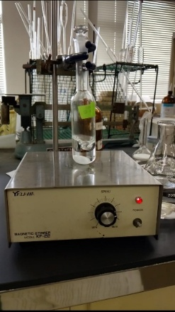
Figure 4 Magnetic rotor
- During this time, I put in approximately 250 mL of ethanol onto the 300mL Erlenmeyer flask.
- Afterwards, I placed a largish magnetic rotor on this Erlenmeyer flask. While agitating the ethanol with a magnetic stirrer, add the toluene polystyrene solution and filter through a glass filter to separate the polystyrene into powder or cotton-like form. Wash the polymerization vessel with a small quantity of toluene, and add and filter this liquid with the glass filter. Toluene is used since it is a good solvent. (Figure 5)
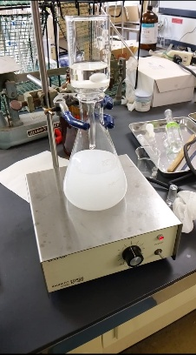
Figure 5 Magnetic rotor
Note: If toluene is used too much, the solvent composition in the Erlenmeyer flask will be biased toward the good solvent(toluene) and the precipitated solvent may dissolve again. Therefore, the toluene used for washing out needs to be minimized (washed twice with 2-3 mL).

After adding, continue agitating for 10-20 minutes. During this time, use a wash bottle in a drafty area. Place it upside-down on a piece of paper after cleaning the glass filter with a small amount of toluene, so that it can be used again).

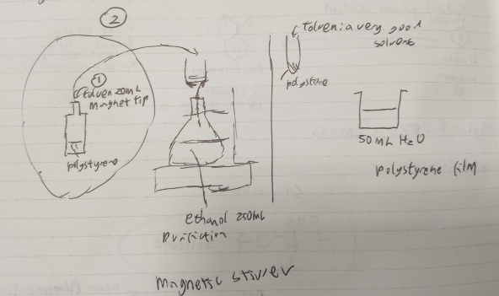
Figure 6 The schematic of 2nd day of experiment
- If we continue to agitate for 10-20 minutes, then turn off the switch to the stirrer and leave it for a while, the polystyrene will precipitate. Insert the glass filter used in step 3 into the perforated silicon rubber stopper and attach it to the suction filtration bottle. Perform suction filtration on the polystyrene mixture using the water flow pump and collect polystyrene precipitate in the previously cleaned glass filter.
The schematic of steps 2-3 is explained in Figure 6.
After this process, the result was a polystyrene film that could be used for testing.
Experiment Day 3: Infrared Absorption Spectroscopy (Identification of Molecular Structure) 20th October
Infrared light is absorbed by most organic materials. The infrared spectrum represents, quantitatively, the amount of infrared light that has been absorbed. The molecular vibrations of the measurement sample cause infrared light to be absorbed. It is possible to measure solid, liquid, and gaseous samples as part of the infrared absorption spectrum. Current infrared spectrophotometers are capable of high-speed scanning and highly accurate photometry with automatic integration of measurement results.
A. Fourier Transform -Infrared (FT-IR):
- Characteristics of FT-IR)
- Possible to perform the analysis while largely retaining the original form of the sample
- Can be performed in a non-destructive way
Due to the above, it is capable of being used as a general-purpose instrument in organic and polymer chemistry.
The measurement results are analyzed in terms of 1) Comparison with standard spectra 2) Estimating the molecular structure from the position(wavenumber) of the signal and the shape.
- Principle of FT-IR (Part 1):
Fourier transform spectrometer: *
Currently, almost all spectrometers operating in the infra-red and near-infrared use ‘Fourier transform’ techniques for spectral detection and analysis.
The heart of a Fourier transform spectrometer is a Michelson interferometer (Figure 7), a device for analysing the wave lengths present in a composite signal. The Michelson interferometer works by splitting the beam after it has passed through the sample into two and arranging for them to take different routes through the instrument before eventually recombining at the detector.
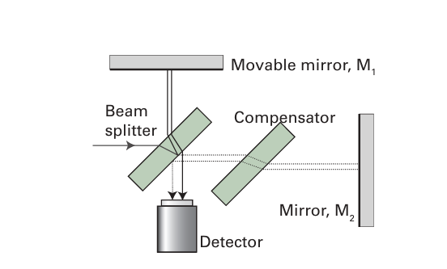
Figure 7
One beam is reflected from mirror M1 and one from mirror M2 ; by moving M1 it is therefore possible to introduce a difference in the length of the path traversed by the two beams. Consider first the simplest case in which a beam of mono chromatic light of wavelength λ is passed into the interferometer. If the path length difference p is 0, the two beams interfere constructively; the same is true if p is an integer number of wavelengths: λ, 2λ, 3λ,…. If p is one half of a wavelength, the two beams interfere destructively and cancel; the same is true if p is an odd multiple of half-wavelengths: λ/2, 3λ/2, 5λ/2,…. Therefore, as the mirror M1 is moved the detected signal goes through a series of peaks and troughs depending on whether the two beams interfere constructively or destructively, and the net signal varies as 1 + cos(2πp/λ), or 1+cos(2πp$\overline{v}$).
In a spectroscopic observation a mixture of radiation of different wavelengths and intensities is passed into the spectrometer. Each component gives rise an interference pattern proportional to 1+cos(2πp$\overline{v}$), and the signal recorded by the detector is their sum. Thus, if the intensity of the radiation entering the spectrometer consists of a mixture of wavenumber ${\overline{v}}_{i}$ with intensities I(${\overline{v}}_{i}$), then the signal measured at the detector is given by the sum
$I(p)=\sum_{i}{ I({\overline{v}}_{i})\{1+cos⁡(2π}{\overline{v}}_{i}p)$}
A plot of I (p) against p, which is detected by the system and recorded, is called an interferogram. The problem is to find I($\overline{v})$, the variation of the intensity with wavenumber, which is the spectrum, from the measured I (p). This conversion can be carried out by using a standard mathematical technique, called the Fourier transform, which involves evaluating the integral
I($\overline{v})$= $4\int_{0}^{∞}{\left\{I\left(p\right)-0.5I\left(0\right)\right\}cos⁡(2π{\overline{v}}_{i}p})dp$ Fourier transform
In practice, the measured values of I(p) are digitized, stored in a computer attached to the spectrometer, and then the Fourier transform is computed numerically.
* Reference:
From Physical Chemistry by Atkins et al, 12th edition, Focus 11A. General features of molecular spectroscopy, page 437
For this experiment, we perform the measurement operation using a personal computer connected to the spectrophotometer.
3. Principle of FT-IR (Part 2):
From the Advanced Lab textbook (attached in the appendix of the textbook):
(Figure 8 and 9 of this report):
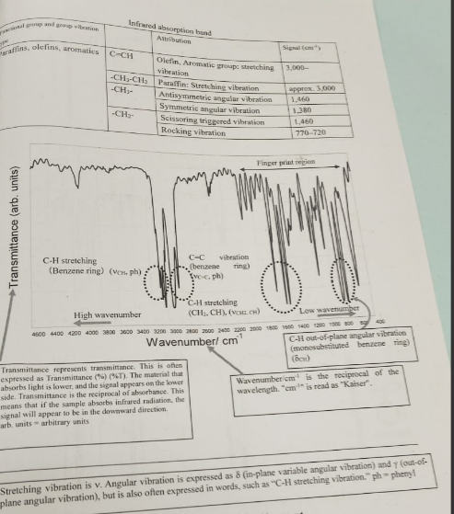
Figure 8 Correlation table and Example of the IR assignment
- Vibrational infrared spectrum*:
Molecules are flexible structures with atoms and groups of atoms able to rotate around covalent single bonds. Covalent bonds bend and stretch. All energy changes within a molecule are quantised: subdivided into small but well-defined increments.

We can cause an atom/molecule to undergo a transition from energy state E1 to a higher energy E2 by irradiating it with electromagnetic (EM) radiation corresponding to the energy difference between states E1 and E2. When the atom/molecule returns to the ground state, an equivalent amount of energy is emitted. When a compound is irradiated with EM radiation of various wavelengths, it absorbs energy of wavelengths, while the wavelengths not absorbed simply pass through/ are reflected from the sample unchanged. In infrared(IR) spectroscopy, when we irradiate the compound with infrared radiation, this radiation is absorbed when its energy(frequency) is exactly equal to the energy required to excite a molecule to a higher energy state. Because different functional groups have different bond strengths, the energy required to bring about these transitions varies from one functional group to another. Thus, in IR spectroscopy, we detect functional groups by the vibrations of their bonds.

The infrared region of the EM spectrum covers the range of wavelengths from 7.8 X 10 ^-7 m to 2.0 x 10^-3 m. In chemistry, however, we routinely use only the portion that extends from 2.5 x 10^-6 to 2.5 x 10^-5m. This region is the vibrational infrared region, and we commonly refer to radiation in this region by its wavenumber $\overline{v}$, the number of waves per centimetre. Expressed in wavenumbers, the vibrational region of the IR spectrum extends from 4000 to 400 ${cm}^{-1}$. An advantage of using wavenumbers is that they are directly proportional to energy: the higher the wavenumber, the higher the energy of radiation.

Example infrared spectra are in Figures 8 and 9. The horizontal axis is calibrated in wavenumbers (${cm}^{-1}).$ The vertical axis measures transmittance, which is the reciprocal of absorbance. (The higher the transmittance, the lower the absorbance, or 100% transmittance= 0% absorbance). Thus, the baseline for an infrared spectrum is at the top of the chart, and the absorbance of radiation corresponds to a trough/ valley. However, it is common to refer to infrared absorption as peaks.

b) Molecular vibrations *
Atoms joined by covalent bonds are not permanently fixed in one position, but instead undergo continuous vibrations relative to each other. The transitions between vibrational energy levels in a covalent molecule can be induced by an absorption in the IR region of the EM spectrum.

For a molecule to absorb IR radiation, the bond undergoing vibration must be polar, and its vibration must cause a periodic change in the bond dipole; the greater the polarity of the bond, the more intense is the absorption. Any vibration that meets these criteria is said to be infrared active.
The simplest vibrational motions in molecules giving rise to the absorption of IR radiation are stretching and bending motions. Data on absorption patterns of selected functional groups are collected in tables called correlation tables. The correlation table used to analyse the infrared spectrum result in this report is in Figure 8. (The table with the column Functional Group and Group vibration types)
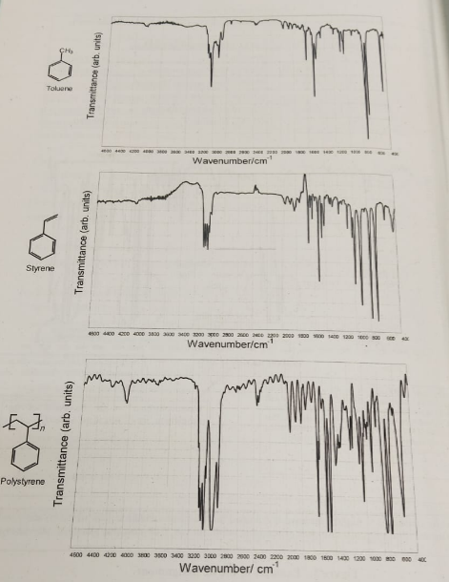
Figure 9 Standard IR spectra of toluene, styrene, and polystyrene
*Reference:
1. Advanced Labs 1 textbook, appendix on guide of infrared spectroscopy (Figures 8 and 9 in this report)
2. Chemistry by Blackman, Bottle, et. al. , Wiley, Chapter 19: Spectrospy
B. Steps done in Experiment Day 3
For this experiment, we used an FT/IR-4600 infrared spectrophotometer to measure IR spectra. The principle of the IR spectra and the example information that can be obtained are written in Figures 8 and 9.
Step 1: Use tweezers/microspatula carefully and remove polystyrene film from the beaker, placing it on a JK wiper/Kimwipe to remove any remaining water droplets.
Step 2: Select as large a sample piece as possible, place it on a piece of cardboard with a hole with it, and set this in the measurement light path of the sample chamber of the spectrophotometer.
Step 3: Perform the measurement operation using a personal computer connected to the spectrophotometer.
Step 4: After the measurement operation, the IR spectra result is printed out. We then analyse the result. (Figure 10)
The vertical axis is transmission, which is the reciprocal of infrared absorption. In other words, the signal in the downward direction expresses infrared absorption. The horizontal axis is read in Kaiser (${cm}^{-1}$ ). The principle of the IR spectra and the example information that can be obtained are written in Figure 7 and 8.
Step 5: The powdered polysterene (Figure 12) is measured. The weight will then be used to calculate the synthetic yield of the polymerization process in the end of this report. The powdered polystyrene is left and kept as a collection in the lab.
The polysterene film is attached to the cover of this report and inside a plastic ziplock. (Figure 10)
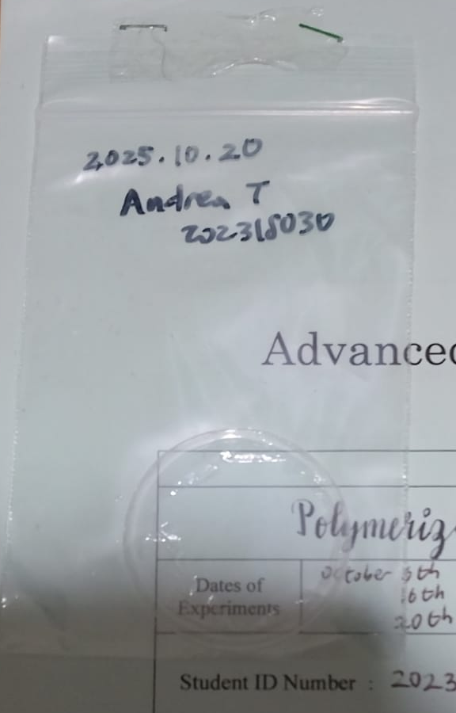
Figure 10 Polystyrene film formed, which is used for the infrared spectroscopy testing
Results and Discussion
Infrared Assignment and Infrared Absorption Spectra Result
The infrared absorption spectra result is below. (Figure 11)
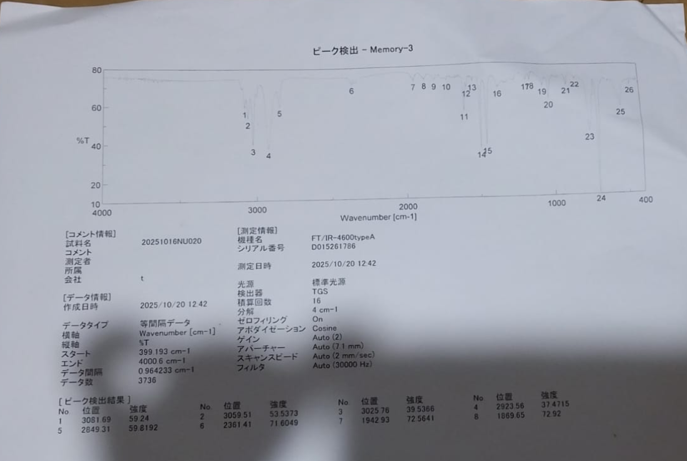
Figure 11 IR Absorption Spectra result
Both original printed out pages of the infrared absorption spectra measurement result are attached to this report.
The results of the spectroscopy show multiple regions where the transmittance drops significantly namely 1, 2, 3, 4, 5, 11, 14, 15, 23, and 24. Each of these regions correspond to wavelengths where molecular bonds absorb most energy. Peaks 1 to 4, located around 3000cm−1, correspond to the C-H molecular bond vibrations. This is present in the aromatic ring of the polystyrene molecule. The region around 1500cm−1 has peaks no 14 and 15 which correspond to CH2 and CH3 bonds. The peaks 23 to 24 correspond to the rocking vibrations of CH2 around 700cm−1. These results are evidence that the resulting material is indeed polystyrene.
Polymerization yield
Styrene (Monomer) weight: 0.902 g/mL – 1mL- > 0.902 g Polymerization monomer
After the polymerization reaction and process has finished, I obtained mass of 0.6231 g of sampled powder polystyrene (Figure 12)
Thus the synthetic yield of the polymerization process is
Y= (0.6231 g/ 0.902 g) x 100 %= 69.07 % =69.1 %
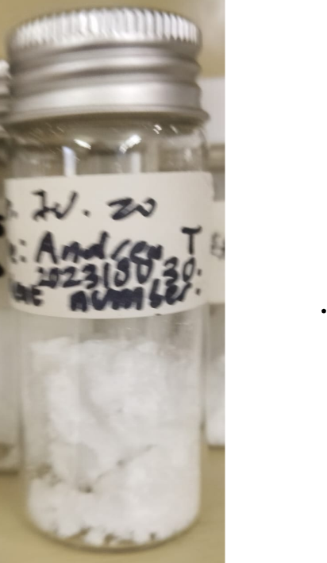
Figure 12 Sampled powder styrene obtained after polymerization experiment

